Introduction

The daily commute can be a source of stress, especially when dealing with long queues and complex ticketing systems. When it comes to train travel, obtaining season passes often involves waiting in lines at stations, navigating fare structures, and missing out on potential cost savings. This not only frustrates passengers but also leads to lost revenue for railway authorities.

eSeason proposes a innovative web application designed to revolutionize the way passengers obtain train season passes. Our user-friendly platform streamlines the application process, promotes cost-effective travel options, and ultimately benefits both passengers and railway networks.

Passengers can now create secure accounts on eSeason. From the comfort of their homes, users can conveniently apply for season passes by selecting their desired travel class (2nd or 3rd), specifying the travel distance (origin and destination), and choosing the duration of the pass (1 week, 1 month, 3 months or 1 year).

eSeason doesn't stop at convenience. We actively promote cost savings for passengers. The system automatically calculates discounts for students and government employees upon verification of their identity through the admin panel. This transparency in fare structures and ease of access to discounts passengers to choose season passes, leading to a more cost-effective commute.

eSeason offers a win-win solution for both passengers and railway authorities. Passengers experience a faster, more convenient application process, benefit from automatic discounts, and enjoy the cost savings associated with season passes. Railway authorities gain a centralized platform to manage applications, verify user identities for discounts, and streamline the entire season pass process. Additionally, by promoting season pass usage, the system encourages passengers, ultimately boosting revenue generation for railway networks.

eSeason is a comprehensive solution that addresses the inefficiencies of the current system, transforming the train travel experience for passengers and railway authorities alike. It's time to embrace a smarter, more convenient, and cost-effective way to commute by train.

Feasibility Report

**Executive Summary:**

"eSeason" is an innovative web application designed to streamline the process of obtaining train season passes, making it easier and more cost-effective for passengers while boosting efficiency and revenue for railway authorities. This feasibility study evaluates the viability of eSeason from market, technical, financial, and organizational perspectives. The findings suggest that eSeason has a strong potential to address the inefficiencies in the current system and enhance the overall train travel experience in Sri Lanka.

**Market Feasibility:**

Commuting by train in Sri Lanka is a popular and eco-friendly option. However, the traditional process for obtaining season passes is cumbersome, involving long queues, complex fare structures, and lack of transparency regarding discounts. This inefficiency deters passengers from using season passes, resulting in lost revenue for railway authorities. eSeason addresses these issues by providing a user-friendly platform that simplifies the application process, promotes cost-effective travel, and encourages the use of season passes.

**Technical Feasibility:**

From a technical standpoint, eSeason's web-based platform is feasible to develop and maintain. Utilizing modern web technologies and frameworks, eSeason can offer a seamless user experience across various devices and browsers. The following tools and technologies will be used to ensure the platform's robustness and scalability:

|  |  |  |
| --- | --- | --- |
| Tool/Technology | Purpose | Source |
| Microsoft Project | Project management tool for planning, scheduling, and tracking project activities, tasks, and resources. | Microsoft Project is a proprietary software product available from Microsoft. |
| Figma | Web-based design tool for creating wireframes, prototypes, and mockups for UI and UX designs. | Figma is a cloud-based program accessible via web browsers. |
| Draw.io | Diagramming and flowcharting application for visually representing system architectures, data flows, and process diagrams. | Draw.io is an open-source program available online. |
| MySQL | Relational database management system (RDBMS) for storing and managing structured data. | The official MySQL website offers downloads and installations for MySQL. |
| XAMPP | Local server stack for developing and testing web apps locally before deployment. | XAMPP is available for download from the Apache website. |
| HTML | Markup language for structuring web content. | HTML is an open standard. |
| CSS | Stylesheet language for formatting web content. | CSS is an open standard. |
| JavaScript | Programming language for adding dynamic behavior and interactivity to web pages. | JavaScript is an open standard. |
| PHP | Server-side scripting language for building dynamic web applications and interacting with databases. | PHP is open source and can be included in the website source code |

**Financial Feasibility:**

The development and deployment of eSeason involve initial investment in technology, development, and marketing. However, the long-term benefits, such as increased revenue from higher season pass adoption, reduced operational costs, and enhanced passenger satisfaction, make it a financially viable project. Detailed cost analysis and projections indicate a positive return on investment within a few years of implementation.

**Organizational Feasibility:**

eSeason requires collaboration between multiple stakeholders, including railway authorities, technology providers, and marketing teams. With a clear organizational structure and well-defined roles, the project can be effectively managed and executed. Regular training and support will be provided to ensure smooth operations and maintenance of the platform.

**Schedule Feasibility:**

To ensure the successful and timely completion of the "eSeason" project, a detailed project schedule has been established. This schedule outlines all key tasks, milestones, and deadlines, ensuring that each phase of the project is completed within a reasonable timeframe.

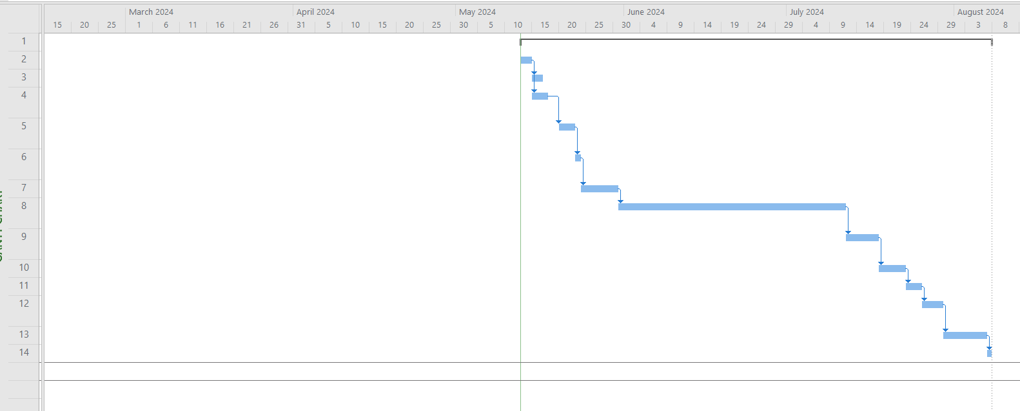

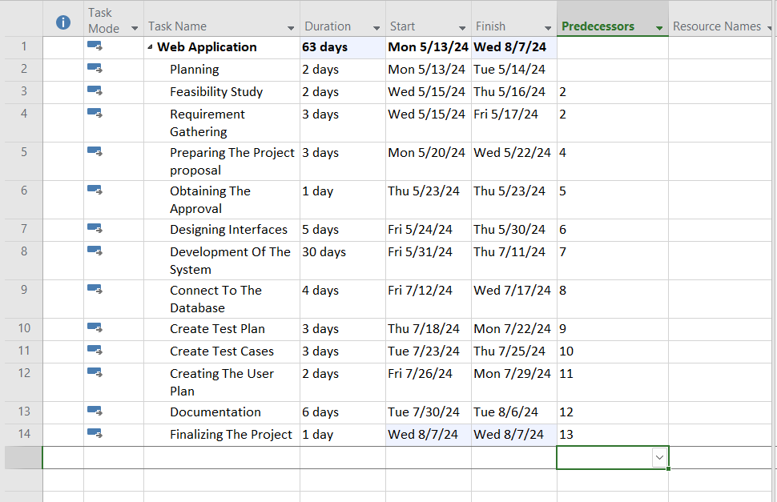

#### Conducting Interviews with Users

We will conduct interviews with passengers, railway authorities, and other stakeholders to understand their viewpoints and gather detailed requirements for the eSeason system. The interviews will use open-ended questions focusing on three principal areas of interest:

##### **Understanding System Requirements:**

Passenger Perspective:

1. What do you want eSeason to achieve for train commuters in Sri Lanka?
2. What features do you think eSeason should have to enhance the train commuting experience?
3. Can you describe how you imagine passengers will use eSeason?

Railway Authority Perspective:

1. What goals do you have for implementing eSeason within the railway system?
2. What administrative features do you think are necessary for managing season pass applications and user accounts?
3. How do you envision eSeason improving your operations and passenger interactions?

**Identifying Current Problems:**

Passenger Perspective:

1. What difficulties do you face in obtaining train season passes using the current system?
2. How do these difficulties affect your daily commute and overall travel experience?
3. Can you share any specific examples of challenges you've encountered with the current season pass application process?

Railway Authority Perspective:

1. What challenges do you encounter in managing and processing season pass applications?
2. How do these challenges impact your efficiency and revenue generation?
3. Can you share specific examples of operational inefficiencies or issues you've faced?

**Proposed Solutions:**

Passenger Perspective:

1. What features do you believe would solve the challenges you mentioned and improve the season pass application process on eSeason?
2. How would you rank these features in terms of importance?
3. Are there any websites or applications you like that you think eSeason could learn from?

Railway Authority Perspective:

1. What administrative tools or features would help streamline the season pass management process?
2. How would you prioritize these features based on their impact on efficiency and revenue?
3. Are there any best practices or systems from other railway networks that you think eSeason should adopt?

#### Surveys and Questionnaires

To gather a broader range of input, we have created a Google Form survey to collect feedback from passengers and railway authorities. The survey link has been distributed through various channels, such as social media, email newsletters, and posters at train stations.

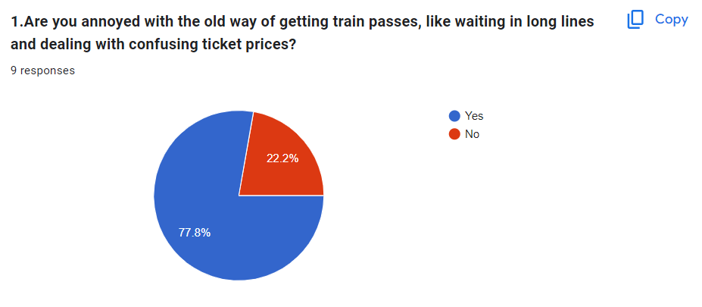

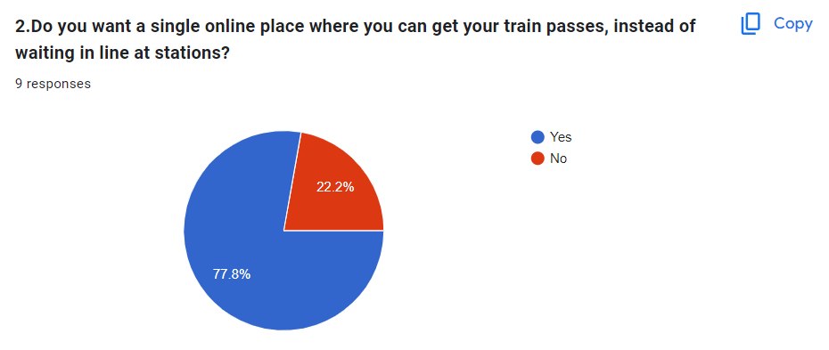

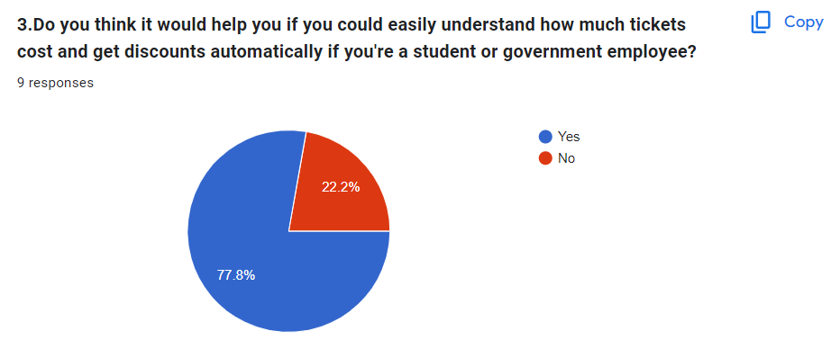

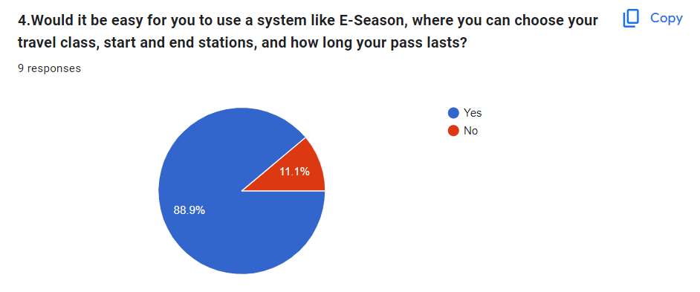

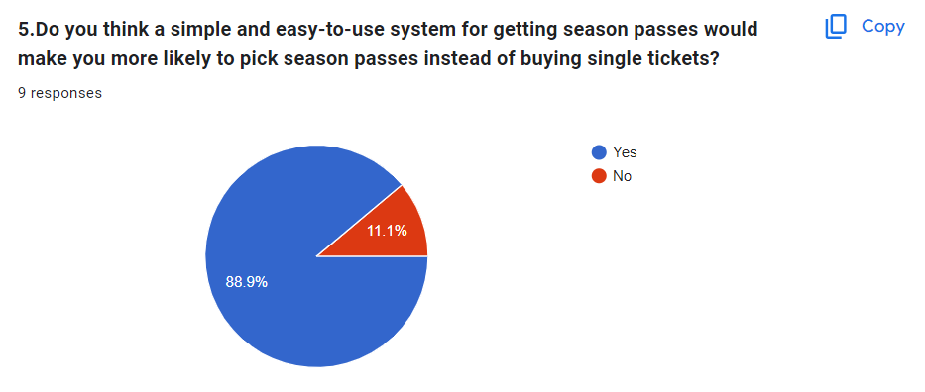

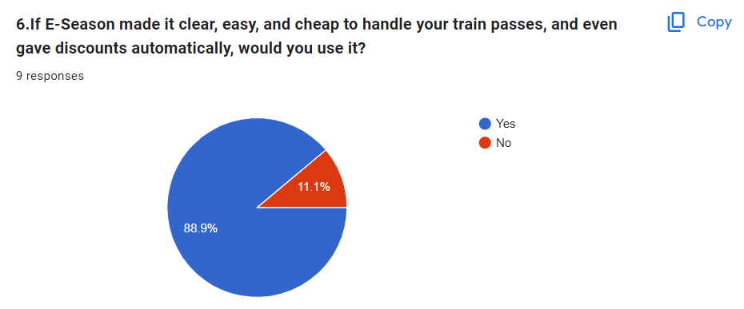

**Resource Identification for eSeason**

**1. Human Resources:**

* Software Engineers:

Responsible for developing both the frontend and backend components of the eSeason platform using HTML, CSS, JavaScript , PHP, and MySQL.

* Project Manager:

Oversees the project, manages timelines, and ensures effective communication among team members.

* System Analysts:

Analyze project requirements and contribute to the planning and design phases.

* Database Administrator:

Designs the graphical user interface of the eSeason platform, ensuring an intuitive and user-friendly experience.

* Quality Assurance Engineer:

Creates test plans and strategies for comprehensive testing of the eSeason platform to ensure its quality and reliability.

2. Technologies Used for Design and Implementation:

* User Interface Design (Figma):
* Design Objectives:

Create an engaging and user-friendly interface for eSeason users.

Ensure intuitive navigation, responsive design, consistency, and accessibility.

* Frontend Development Technologies (Bootstrap):
* HTML:

Provides the structure of web pages.

* CSS:

Styles HTML elements, including layout, fonts, and colors.

* JavaScript:

Adds interactivity and dynamic behavior to web pages.

Enhances user experience with animations, transitions, and form validation.

**Backend Development (MySQL and XAMPP):**

* Database Management (MySQL):

Stores and manages data related to eSeason users, season passes, discounts, and travel details.

* Server-Side Logic (PHP within XAMPP):

Handles user authentication, season pass application processing, discount verification, and payment processing.

Implements security measures to protect user data and transactions.

* Backend Development Review and Testing:

Utilizes MySQL and XAMPP for building, testing, and deploying eSeason.

Conducts rigorous testing to ensure the reliability, security, and performance of the platform.

**3. Hardware Requirements:**

* Processor:

Intel Core i5 Processor or higher.

* RAM:

Minimum 8GB, Recommended 12GB or higher.

* Hard Disk:

Minimum 500GB Hard Disk, Recommended 500GB SSD and 1TB Hard Disk.

* Network:

Fast and reliable network adapter with both wireless and wired (LAN cables) network facilities.

**4. Software Requirements:**

* Operating System:

Windows 10.

* Database Management System:

MySQL 5.6 or higher versions.

* Server Software:

XAMPP Server or similar software for local development and testing.

**Risk Analysis Report for eSeason - A Platform for Sri Lankan Train Passengers**

|  |  |  |  |  |  |
| --- | --- | --- | --- | --- | --- |
| RID | Risk | Probability | Impact | Score | Resolution Strategy |
| R1 | Technical Issues |  |  |  | Mitigate: Conduct thorough testing during development, implement robust error handling and monitoring |
| R2 | User Adoption |  |  |  | Mitigate: Implement user-friendly design, provide tutorials and onboarding support |
| R3 | Content Quality and Moderation |  |  |  | Mitigate: Establish clear guidelines for content creation and moderation, implement reporting features |
| R4 | Competition from Existing Platforms |  |  |  | Accept: Analyze competitors, differentiate eSeason with unique features and value propositions |
| R5 | Data Privacy and Security |  |  |  | Mitigate: Implement strong encryption, secure authentication, and regular security audits |
| R6 | Funding and Financial Sustainability |  |  |  | Mitigate: Develop a sustainable revenue model, seek investment opportunities or sponsorships |
| R7 | Regulatory Compliance |  |  |  | Mitigate: Stay updated on relevant regulations, consult legal experts for compliance guidance |
| R8 | User Engagement and Retention |  |  |  | Mitigate: Implement gamification, personalized recommendations, and community engagement features |
| R9 | Third-Party Software Integration Risk |  |  |  | Mitigate: Carefully select reliable third-party software, ensure proper integration and ongoing support |
| R10 | Failures in Webserver |  |  |  | Mitigate: Use a reliable web server, perform regular maintenance, and have a backup server in place |

**Probability & Impact**

* Red: High Risk (Probability, Impact, or Score ≥ 7)
* Yellow: Medium Risk (Probability, Impact, or Score between 5 and 6)
* Green: Low Risk (Probability, Impact, or Score ≤ 4)

**Score**

* Red: High Risk (Score ≥ 50)
* Yellow: Medium Risk (Score between 30 and 49)
* Green: Low Risk (Score < 30)

**Risk Mitigation Strategies:**

* Technical Issues:

Conduct thorough testing during development.

Implement robust error handling and monitoring systems.

* User Adoption:

Implement a user-friendly design.

Provide tutorials and onboarding support to new users.

* Content Quality and Moderation:

Establish clear guidelines for content creation and moderation.

Implement reporting features for inappropriate content.

* Competition from Existing Platforms:

Analyze competitors and differentiate eSeason with unique features.

Focus on providing value propositions tailored to Sri Lankan train commuters.

* Data Privacy and Security:

Implement strong encryption and secure authentication mechanisms.

Conduct regular security audits to identify and address vulnerabilities.

* Funding and Financial Sustainability:

Develop a sustainable revenue model.

Explore investment opportunities or sponsorships to support platform growth.

* Regulatory Compliance:

Stay updated on relevant regulations and compliance requirements.

Consult legal experts for guidance on regulatory compliance.

* User Engagement and Retention:

Implement gamification elements to incentivize user engagement.

Provide personalized recommendations and community engagement features to enhance user retention.

* Third-Party Software Integration Risk:

Carefully select reliable third-party software.

Ensure proper integration and ongoing support.

* Failures in Webserver

Use a reliable web server, perform regular maintenance, and have a backup server in place to ensure high availability and reliability.

Conclusion:

In conclusion, the risk analysis for "eSeason" highlights potential challenges and uncertainties that may arise during the development and operation of the platform. While these risks pose threats to the success of eSeason, they also present opportunities for proactive mitigation and strategic planning. By implementing the recommended risk mitigation strategies and maintaining vigilance in monitoring and addressing emerging risks, eSeason can navigate the complexities of the commuter market in Sri Lanka and position itself for long-term success. With a steadfast commitment to quality, security, and user engagement, eSeason has the potential to become a transformative force in enhancing the experience of Sri Lankan train commuters, driving growth and innovation in the regional transportation ecosystem.

# Design of the system database

## **Entity Relationship Diagram**

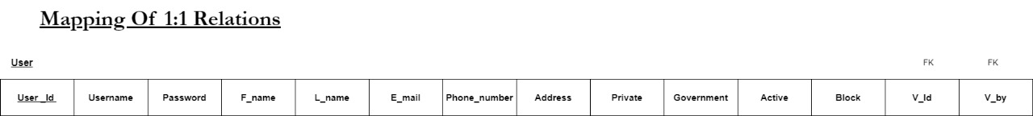

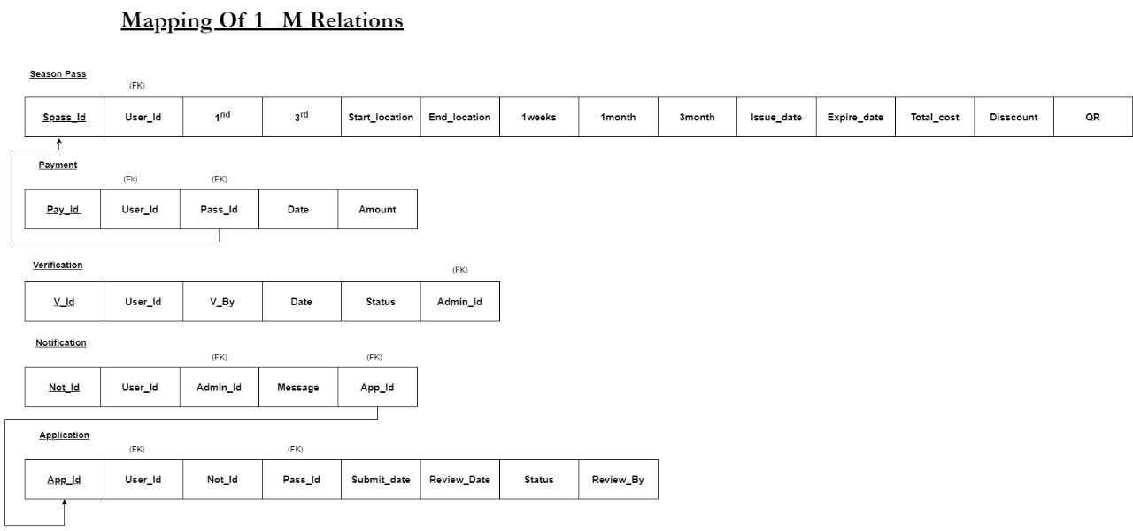

## Final Relational Model

# System Design

# Data Flow Diagrams

## Context Diagram

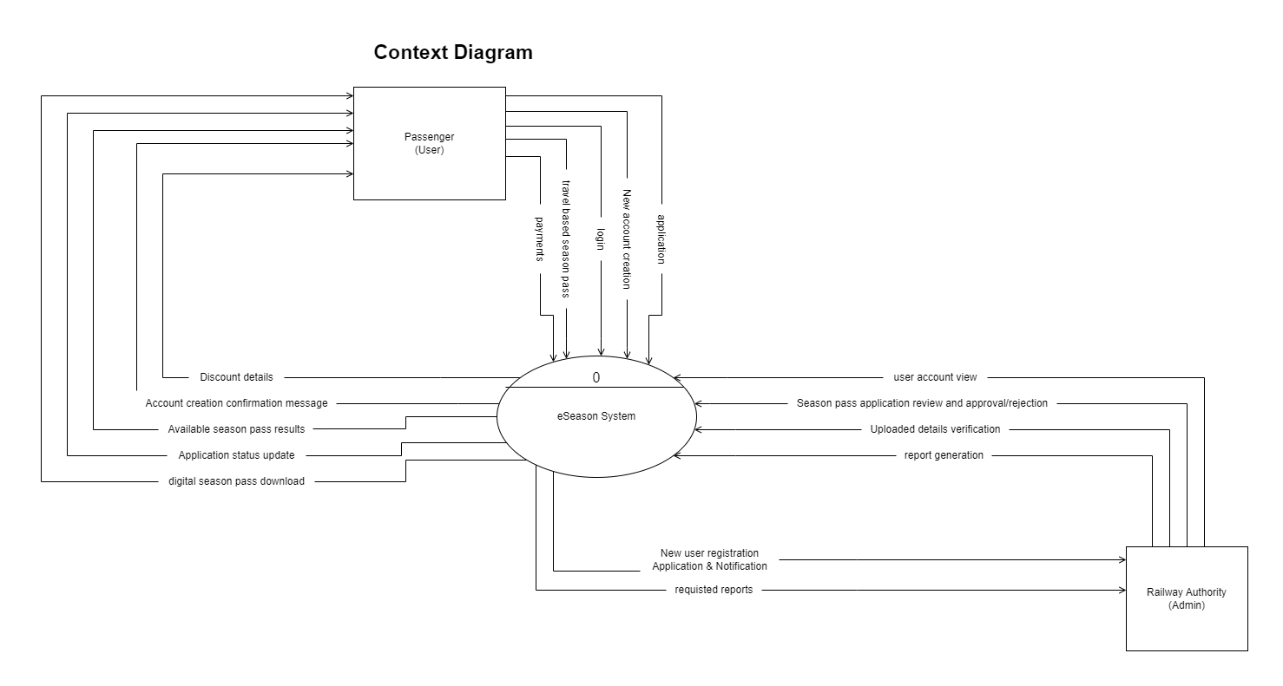

Level 0 Diagram

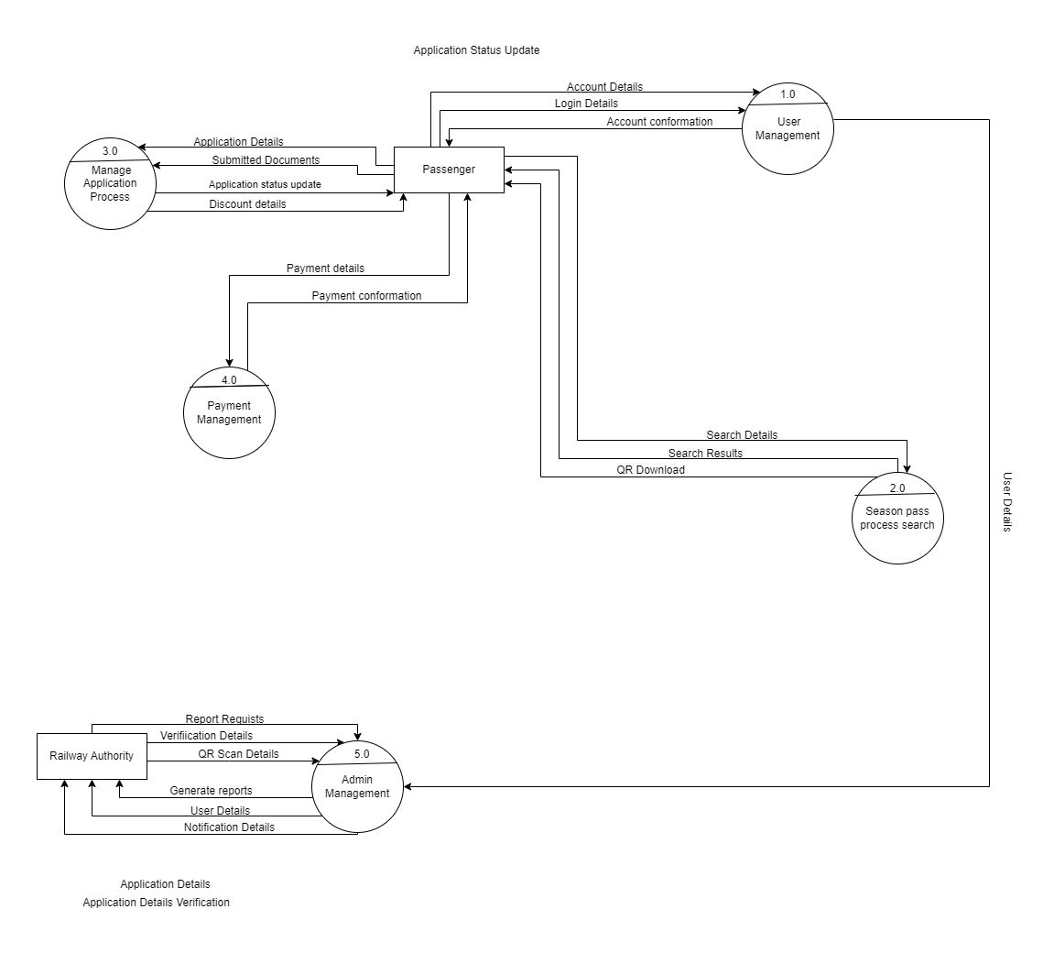

Level 1 Diagram

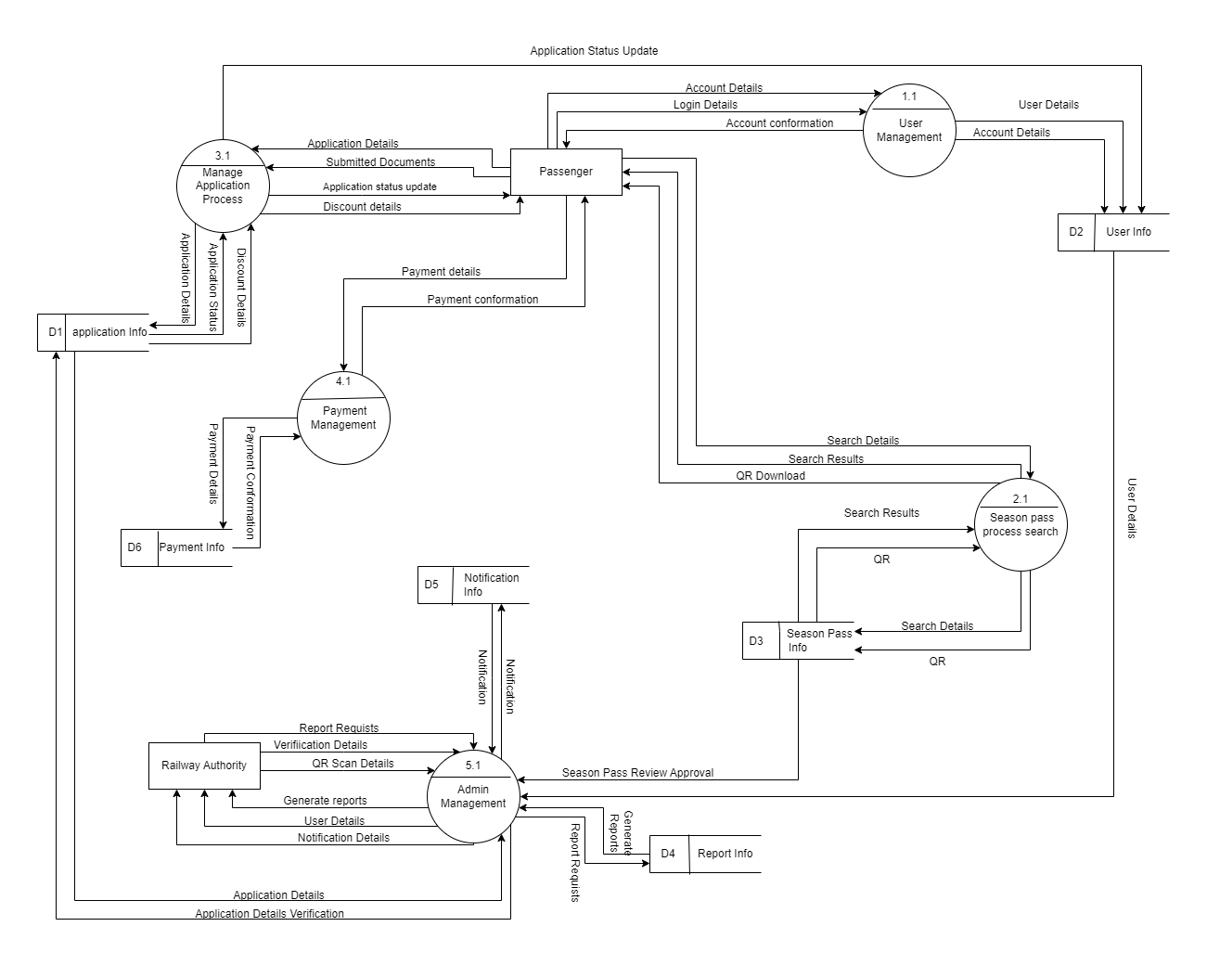

# Sequence Diagram

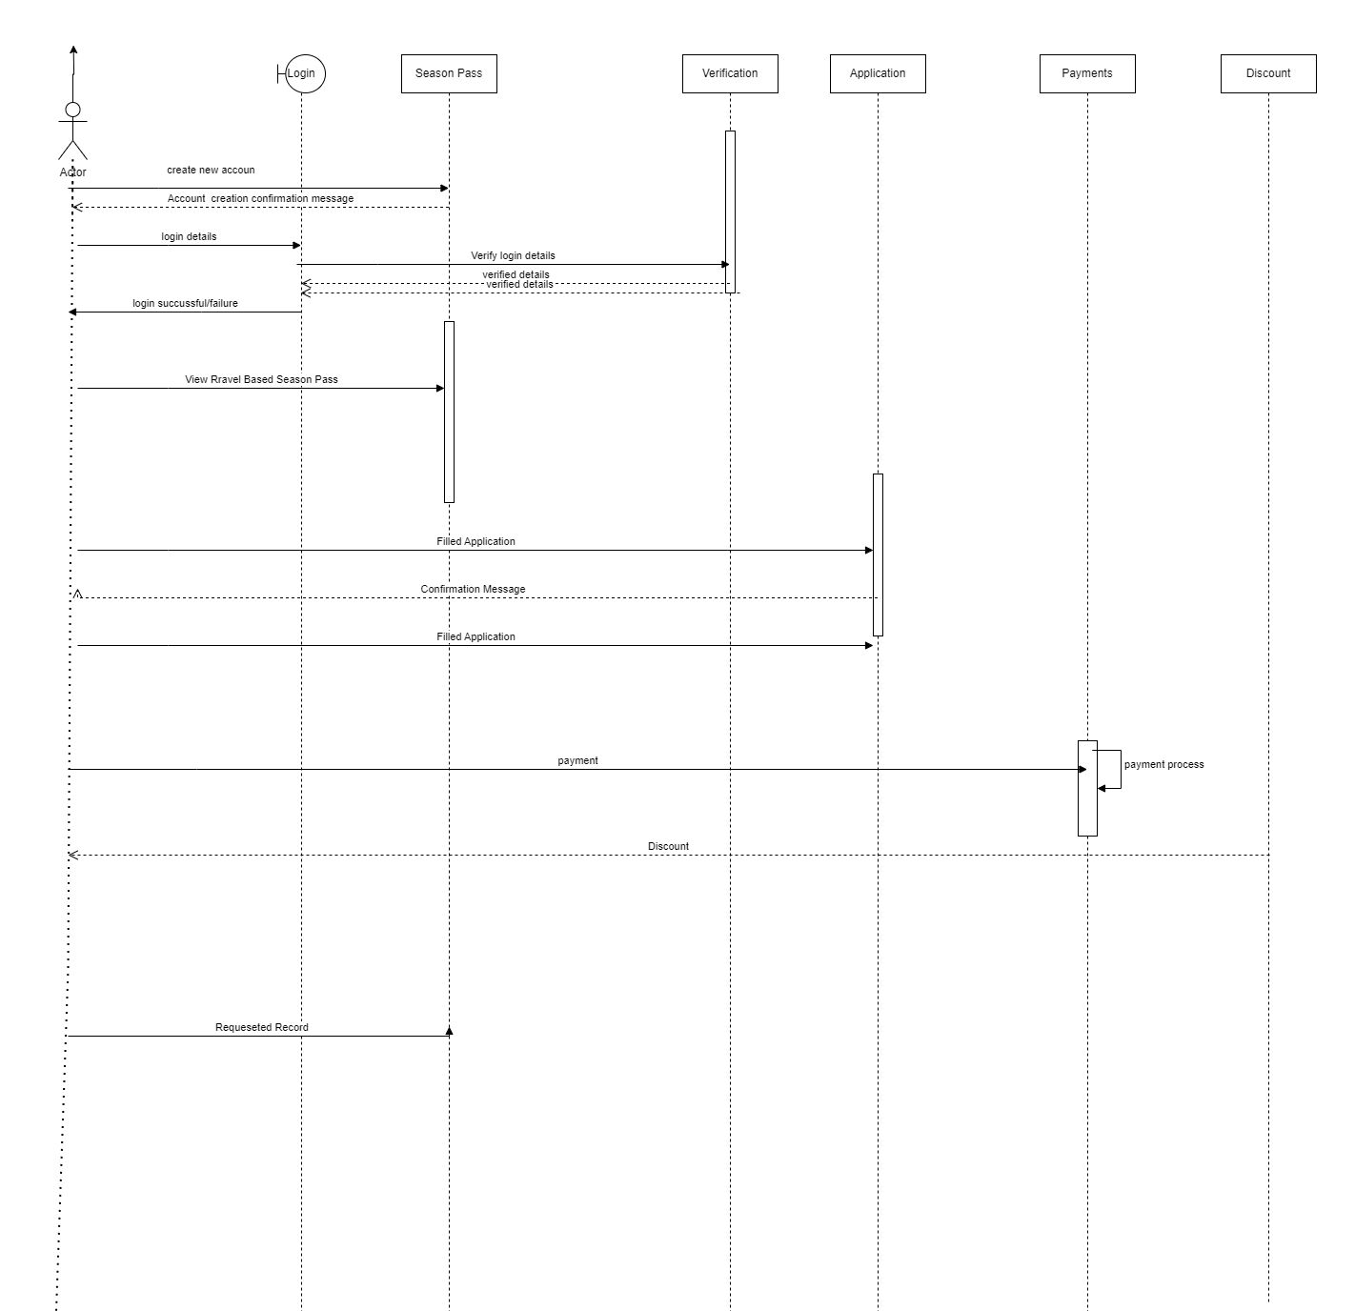

# UML Diagram

## Use case Diagram

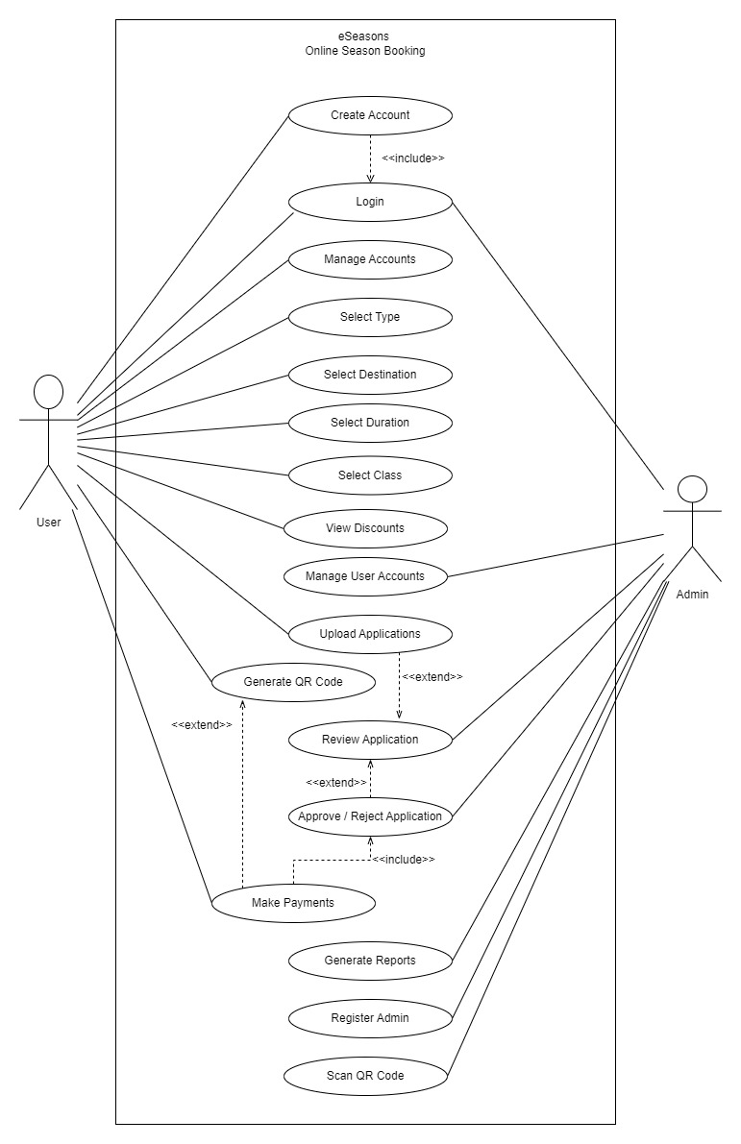

Interfaces

User Homepage

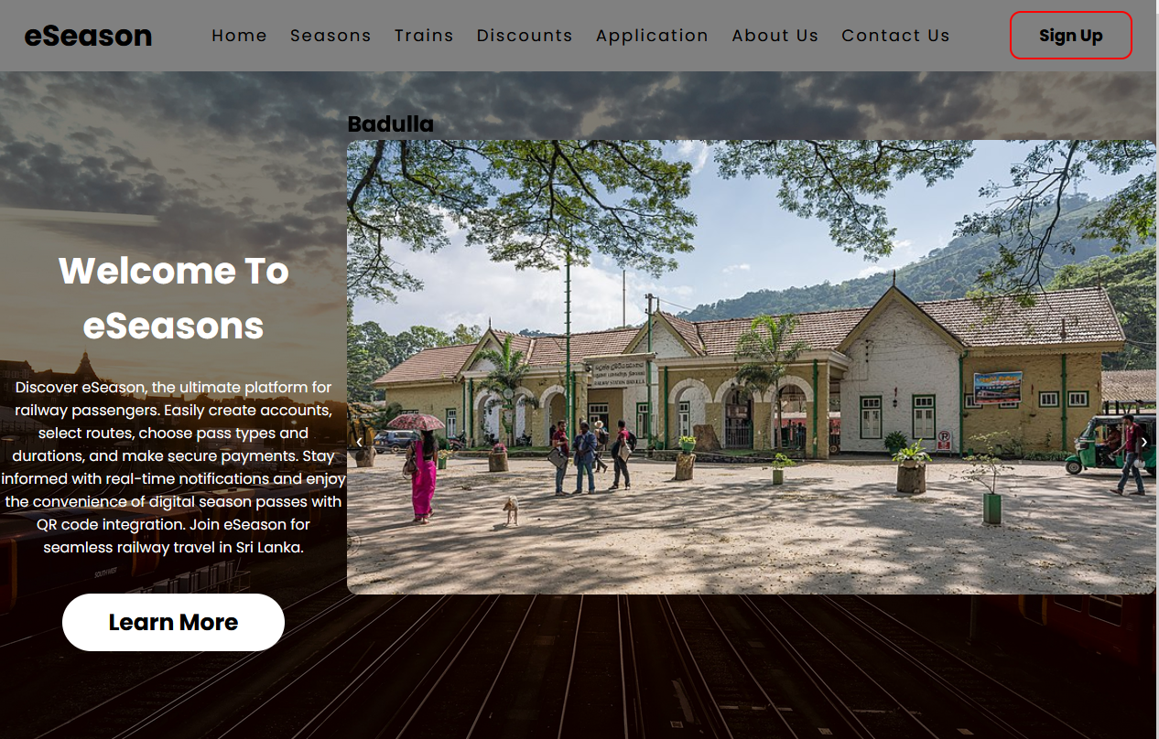

Seasons Page

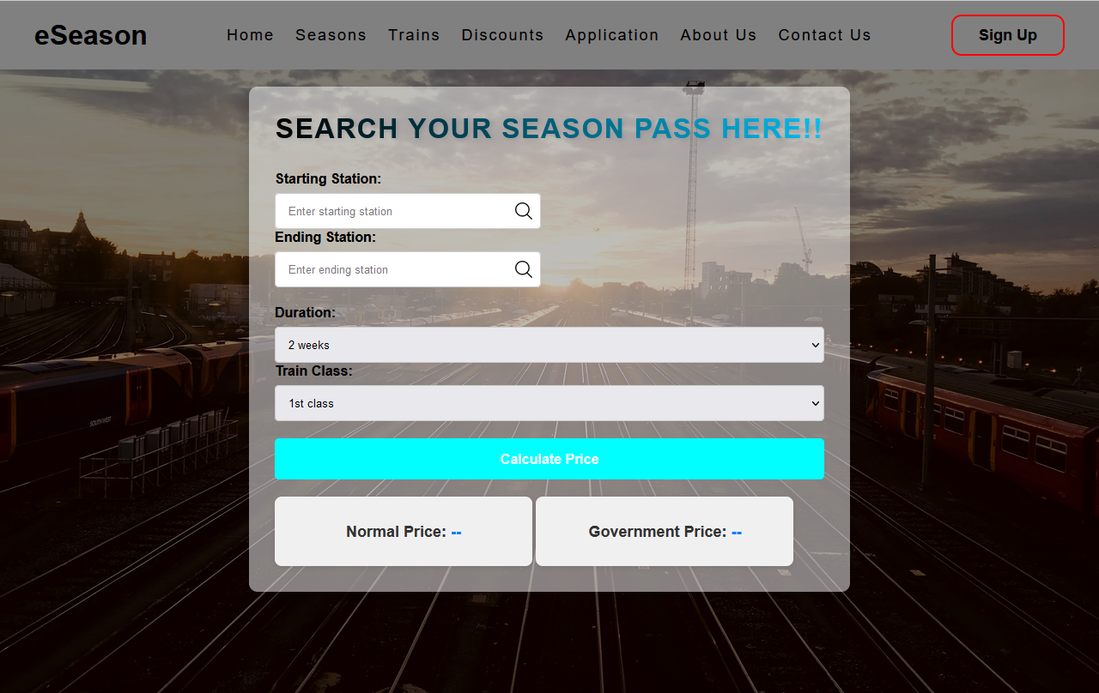

Train Classes Page



Discount Page

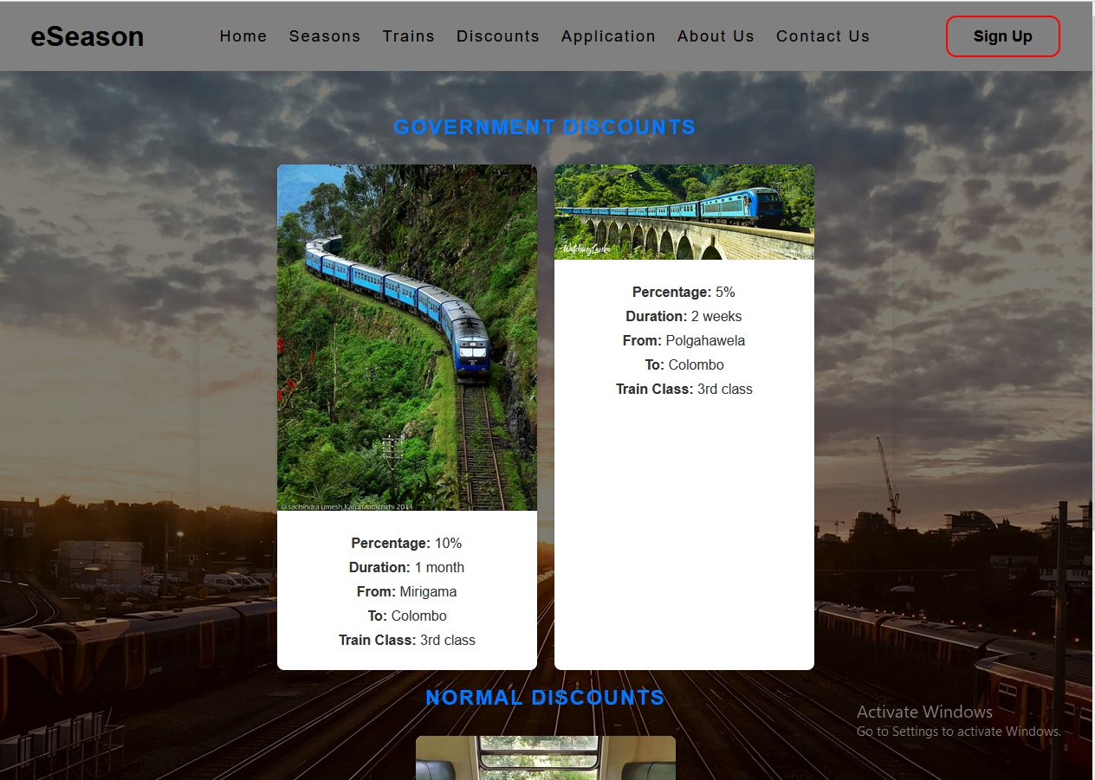

About Us Page

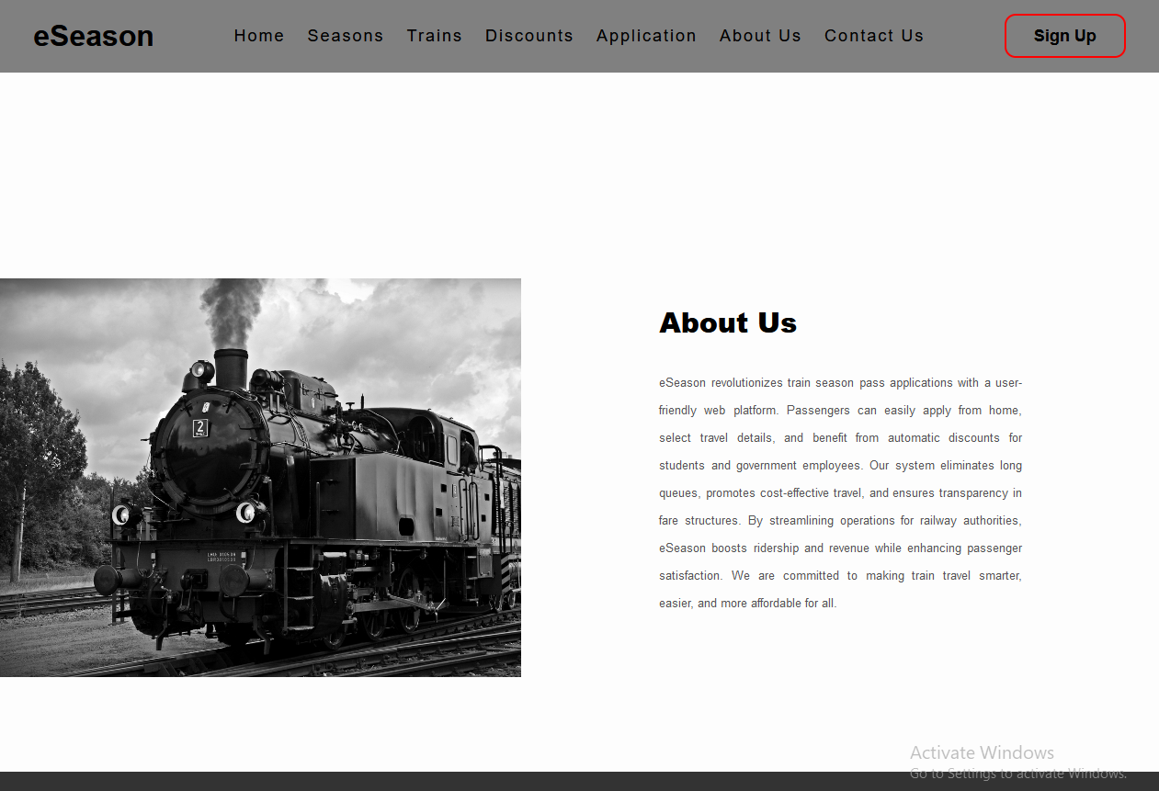

Contact us page.

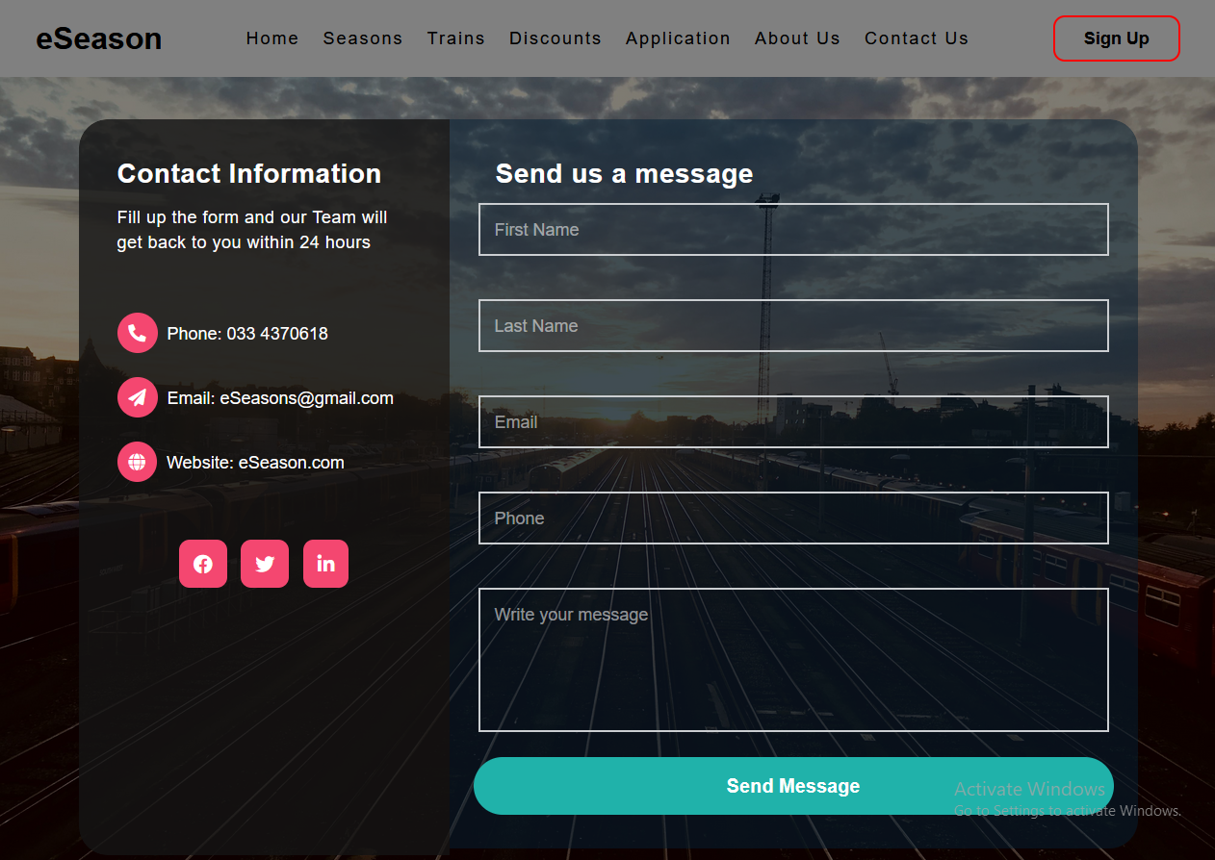

Admin Interfaces

Season Requests

Season Requests

Pending Requests

Approved Requests

Total Requests

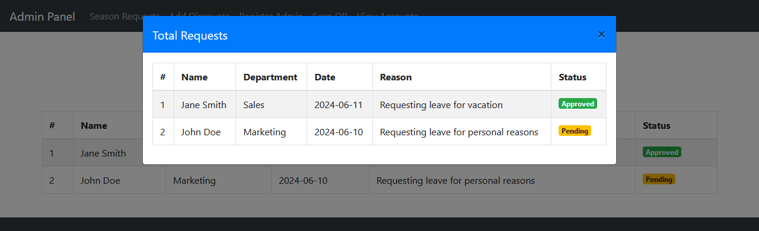

Add Discounts

Back – End Functions

Database connection

Calculate season price.

Autocomplete input fields.

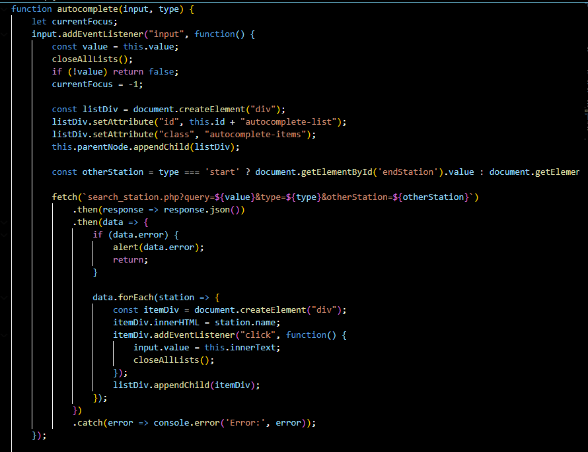

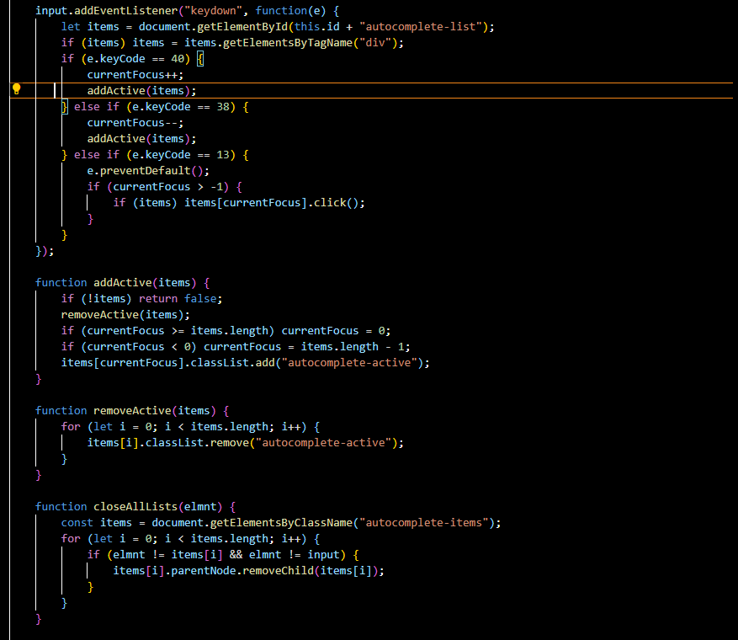

Discount Page

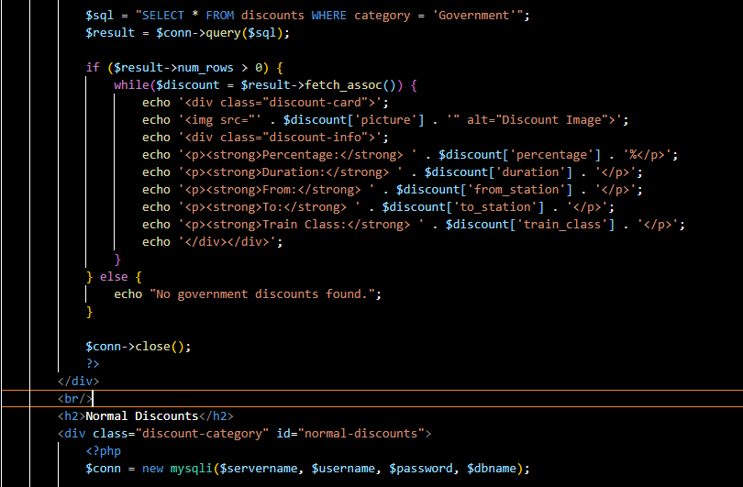

Add Discount Page

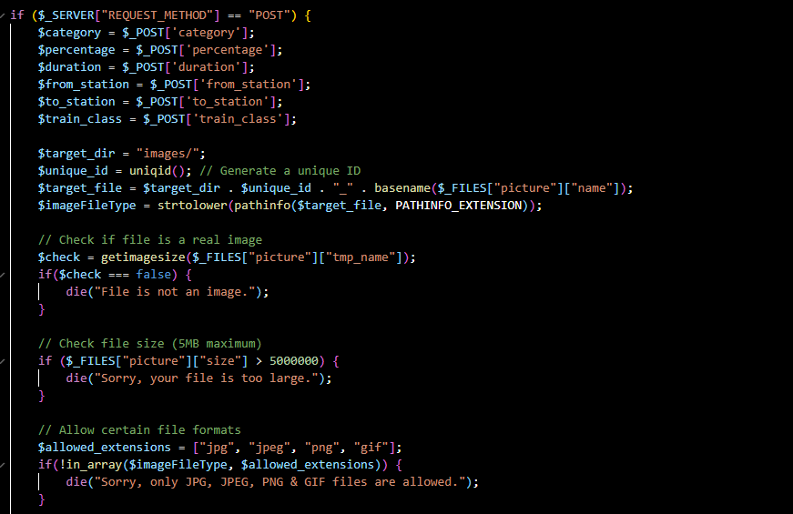

Test Plan

|  |  |  |  |
| --- | --- | --- | --- |
| **Test ID** | **Case Name** | **Scenario** | **Expected Result** |
| Test 1 | User Log In | Input valid log in details. | If log in details are valid, page will be redirected to User page. |
| Test 2 | User Log In (Invalid) | Input invalid log in details. | User is shown an error message indicating invalid username or password. |
| Test 3 | Admin Log In | Input valid admin log in details. | If log in details are valid, page will be redirected to admin dashboard. |
| Test 4 | Admin Log In (Invalid) | Input invalid admin log in details. | Admin is shown an error message indicating invalid username or password. |
| Test 5 | Create User Account | Input valid details for creating a user account. | User account is created, and user is redirected to the log in page with a success message. |
| Test 6 | Create Admin Account | Admin inputs valid details for creating a new admin account. | New admin account is created, and the admin is redirected to the admin dashboard with a success message. |
| Test 7 | Submit Season Pass Application | User fills and uploads the season pass application correctly. | Application is submitted successfully, and the admin receives a notification for review. |
| Test 8 | Review Applications | Admin accesses the list of submitted season pass applications. | Admin can view details of each application including applicant information and pass type. |
| Test 9 | Approve Application | Admin approves a submitted season pass application. | Application status changes to approved, and the user is notified via notification. |
| Test 10 | Reject Application | Admin rejects a submitted season pass application. | Application status changes to rejected, and the user is notified via notification. |
| Test 11 | Manage User Accounts | Admin views the list of all user accounts. | Admin can see user details including username, email address, destinations, and duration. |
| Test 12 | Block User Account | Admin blocks a user account. | User account is blocked, and the user receives a notification about the block. |
| Test 13 | Search User Accounts | Admin searches for a user account using user ID or NIC number. | Relevant user account is displayed in the search results. |
| Test 14 | Generate Reports | Admin generates a report on passenger registration and discount types for a specific time frame. | Report is generated and displayed correctly based on the selected time frame. |
| Test 15 | Select Season Type | User selects a season type (government or private) after registration. | User is directed to the appropriate page based on their selected season type. |
| Test 16 | Search Destination | User searches for a railway station using the station name. | Relevant railway stations matching the search query are displayed. |
| Test 17 | Select Duration | User selects a duration (2 weeks, 1 month, or 3 months). | Selected duration is saved, and the user can proceed to the next step. |
| Test 18 | Select Train Class | User selects a train class (second class or third class). | Selected train class is saved, and the user can proceed to the next step. |
| Test 19 | View Discounts | User views available discounts. | Discounts are displayed with details like percentage off, applicable season pass types, and validity period. |
| Test 20 | Add Discounts | Admin Adds new discounts. | A message show discount are added and the new discount will appear in the discount page. |
| Test 20 | Make Payment | User makes a payment for the season pass. | Payment is processed successfully, and a confirmation message is displayed. |
| Test 21 | Generate QR Code | User generates a QR code after making a payment. | QR code is generated, and the user can download the QR code image. |
| Test 22 | Scan QR Code | Admin scans a user's QR code. | Admin is directed to the user's account details linked to the QR code, verifying the user's season pass. |